In the seventeenth and eighteenth centuries all major European powers had adopted a policy. The logic behind mercantilism was that a state must have a “favorable balance of trade” so that gold and silver would not flow out of the country to purchase needed manufactured goods or food from foreign countries. In essence mercantilism came to mean that colonies existed for the good of the mother country.
In 1651 Parliament adopted a Navigation Act requiring that all goods imported into England or the colonies must arrive in English ships. In addition, the majority of the crew must be English. Colonists were considered Englishmen and colonial ships, English ships under the 1651 Act.
The law also required that certain specified goods must be shipped only to England or the colonies. These “enumerated” goods were tobacco, cotton, indigo, sugar, and a few other items. In 1663 Parliament further required that all colonial goods had to be shipped directly to England. When goods arrived a duty or tax had to be paid before reshipment to another country.
American merchants sent fish, livestock, flour, and lumber to the British West Indies in return for sugar, molasses, indigo and other products including citrus fruits that could be sent to Britain in exchange for manufactured goods that were then carried back to the North American colonies.
Columbian Exchange: the trading of Foods, Plants, and Livestock between Europeans and Native Americans.
Triangular Trade: the trade of raw materials (gold, silver, cotton, tobacco) from the Americas to Europe, manufactured goods (cloth, metal goods etc.) from Europe to Africa and slaves from Africa to the Americas.
The trip slaves were forced to take from Africa to the Americas was called The Middle Passage. Conditions were horrible and many died of disease, starvation and abuse.
The most harmful introduction to Africa from the Europeans was the gun. Muskets, and cannons made war between African tribes much more frequent and deadly. African tribes would trade captured prisoners as slaves for guns and ammunition.

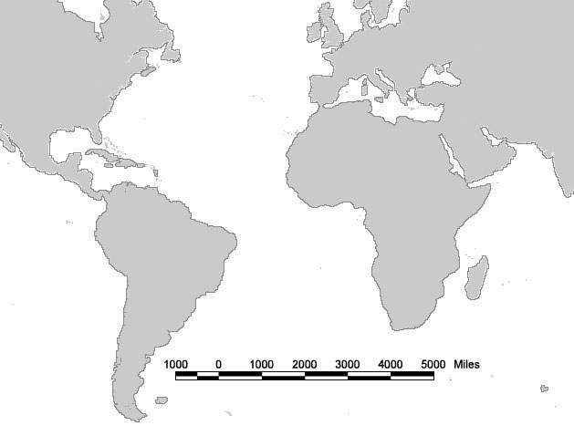
What was the middle Passage?

From the Old World (Europe) | From the New World (Americas)
Grains  Citrus Fruits  Grapes  Livestock  Horses  Cattle  Sheep  Coffee Bean  Onions  Disease  Small Pox  Influenza  Typhus  Measles | Tomato  Potato  Corn  Cacao Beans  Squash  Pineapples  Peppers  Vanilla  Tobacco

What was the lasting impact the Columbian exchange had on the lives of Europeans?
Growth of big business, new foods and raw materials

What is a lasting exchange of the Columbian exchange on Native Americans?
Introductions of livestock changes the lvies of natives forever but not nearly as much as the introductions of old world diseases

What are the PERSIA impacts of the Columbian Exchange?
POLITICAL:

ECONOMIC:

RELIGIOUS:

SOCIAL:

INTELECTUAL:

ART:

