The First Holocaust in the Western World
Flesh Kinkaid
9.3
Death of a Nation
By Hans Koning from Columbus: His Enterprise--Exploding the Myth, 1991
critics/haters

gift or payment

routinely and efficiently with purpose

permanently
To fill the empty ships going back to Castile, to stop his detractors from talking, to prove his success Columbus needed gold. And the following system was adopted for this end.
Every man and woman, every boy or girl of fourteen or older, in the province of Cibao (of the imaginary gold fields) had to collect gold for the Spaniards. As their measure, the Spaniards used those same miserable hawks' bells, the little trinkets they had given away so freely when they first came "as if from Heaven."
Every three months, every Indian had to bring to one of the forts a hawks' bell filled with gold dust. The chiefs had to bring in about ten times that amount. In the other provinces of Hispaniola, twenty-five pounds of spun cotton took the place of gold.
Copper tokens were manufactured, and when an Indian had brought his or her tribute to an armed post, he or she received such a token, stamped with the month, to be hung around the neck. With that they were safe for another three months while collecting more gold.
Whoever was caught without a token was killed by having his or her hands cut off. There are old Spanish prints (I saw them in the collection of Bishop Voegeli of Haiti) that show this being done: the Indians stumble away, staring with surprise at their arms stumps pulsing out blood.
There were no gold fields, and thus, once the Indians had handed in whatever they still had in gold ornaments, their only hope was to work all day in the streams, washing out gold dust from the pebbles. It was an impossible task, but those Indians who tried to flee into the mountains were systematically hunted down with dogs and killed, to set an example for the others to keep trying.
The Spaniards cut out estates for themselves; the Indians still living on this land became their property.
They could be sued to work the land for the owner or could be hired out indefinitely as labor gangs anywhere else. These gangs "were marched all over the island, from one end to the other." The same setup was later introduced in all the new Spanish possessions in the Americas.
The killings continued at no less speed. In 1515 there were not more than ten thousand Indians left alive; twenty-five years later, the entire nation had vanished from the earth. Not one Indian on the island had ever been converted to what Columbus called "our Holy Faith."
The harder black slaves from Africa were brought in to take their place. They would, at the end of the eighteenth century, stage the first and perhaps only successful slave revolt Western history. It made Haiti, the western half of the island, the second independent republic of this hemisphere.
The death toll among the blacks had been frightful too, but they had been brought in such numbers that enough of them survived to form a nation. The statistics (not very precise, obviously) in the archives of Port-au-Prince (now Haiti's capital) show that two million slaves were imported in the century before independence. Of these, and all their children, six hundred thousand survived when their revolution began.

tamed
By that time there was no longer a possibility of mass resistance. the Admiral, his brother Bartholomé, and Hojeda had crushingly defeated the only army the Indians ever managed to bring together. Armor, muskets, swords, horses, and dogs had made the Spaniards invincible.
All prisoners had been hanged or burned to death. The island was so well pacified that a Spaniard could go anywhere, take any woman or girl, take anything, and have the Indians carry him on their backs as if they were mules.
Thus it was at this time that the mass suicides began: the Arawaks killed themselves with cassava poison.
During those two years of the administration of the brothers Columbus, an estimated one half of the entire population of Hispaniola was killed or killed themselves. The estimates run from 125,000 to one half million.
Then, in 1496, when there was obviously not one grain of gold left, the gold tribute system was changed to that of the repartimientos, later known as the encomiendas.

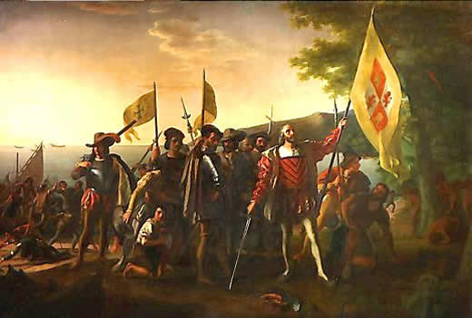
Figure 1: Landing of Columbus (Vanderlyn, 1837)

Text-Dependent Question Creation Worksheet
Please print legibly.
Name of Text: The First Holocaust in the Western World Death of a Nation
First and Last Names of the Question Composers:
Amanda Dwyer; Mario Fitzpatrick; Andrew Yoxsimer

Questions in Finalized Order | Possible answers (words, phrases, sentences with line numbers) to be completed by critiquing group.
How much gold did the natives need to bring the Spanish, and what was the purpose?

What were the motives of the Spanish for killing the natives? Provide evidence.

Why did the Indians have a difficult time resisting the Spanish?

Contrast the experiences the natives and the African slaves had in dealing with the Spanish in Hispanola and Haiti.

Summarize the relationship between the natives and the Spanish. Be sure to support your answer.

What is the author’s purpose for writing this article? Provide evidence supporting your response.
In lines 33-49, use the information to rename the article.

After reading the article, give your definition of “Holocaust.”

Compare and contrast the painting, “Landing of Columbus” with the reading. What is similar and what is different?

Please compose a clear writing prompt or question to follow this close analytic reading. Make sure that your writing prompt/question follows the CCSS writing standards (choose informational or argumentative) and that you use the terminology of the standards. The writing assignment can be a very formal essay or a fairly short piece, as long as it demonstrates that students have understood the document and can use evidence from it effectively.
The author, Hans Koning, gives an alternate perspective on the long held belief that Columbus was a hero and a great explorer who discovered America. How does this article contradict this idea? Develop a claim that stems from this article. Provide at least three examples/pieces of evidence from the text and explain fully and clearly how each piece of evidence supports the claim using your reasoning.

In the space below, create a very specific checklist that helps teachers what exactly to identify in order to measure student success or difficulty with this particular writing assignment on this particular reading. Make sure to use your grade level’s writing standards as a guide. Be clear!
Teachers, the evidence provided in the following lines is likely to be used in student essays.
11-13, 18-21, 22-26, 27-28, 29-32, 33-36, 50-52, 53-54

