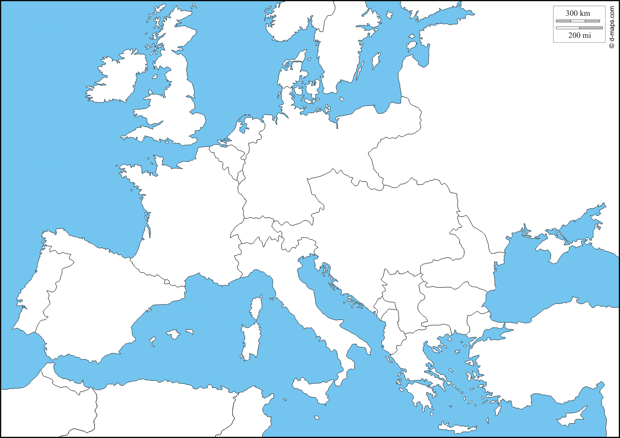
Europe 1914
Use the Map on page 839 to label and color each country on the map.

