NAME_________________________________________________PERIOD________________DATE_________________
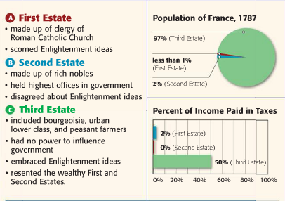Label the pyramid with the proper estate and percentage.
How did this class structure contribute to the beginnings of the French Revolution?

Who benefitted the most from this structure? How and Why?

Which estate was the most oppressed under this system? How and Why

Which PERSIA Category would you place the French Revolution and WHY?

Using the information on the front of this paper, write a claim and support it with evidence.

